Apress LightSwitch 2012 (Tim Leung) – Chapter 11

This chapter shows you how to extend your Silverlight application with custom controls.
To run this example, open the HelpDeskVB or HelpDeskCS solutions. Each solution contains two projects: a project that contains the custom controls and a project that contains the LightSwitch application. You’ll need to make sure that your custom controls project includes correct references to the Microsoft.LightSwitch and Microsoft.LightSwitch.Client DLLs.
The default locations for these DLLs are here:
64 Bit Computer
C:\Program Files (x86)\Microsoft Visual Studio 11.0\Common7\IDE\LightSwitch\Client\
32 Bit Computer
C:\Program Files\Microsoft Visual Studio 11.0\Common7\IDE\LightSwitch\Client\

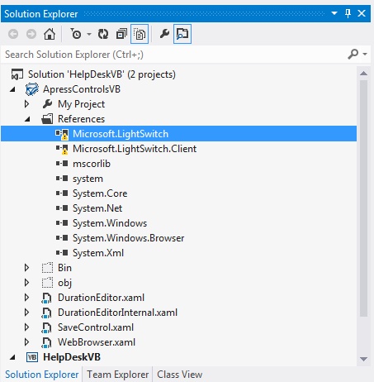
Tim Leung

